**Creating A Custom Tab For Translists**

**Creating a Custom Tab for Translists:**

1. Go to setup page >> type Tabs in Quick Find bar >> click on tabs >> New (under custom object tab)

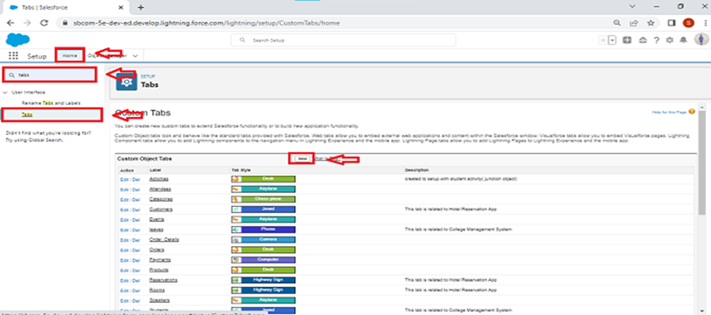

1. Select Object(Translists) >> Select the tab style >> Next (Add to profiles page) keep it as default >> Next (Add to Custom App)  uncheck the include tab >> Save.
2. Make sure that append tab to users' existing personal customizations is checked.

**Note : Similarly, create tabs for Items and products.**